Signs guide:

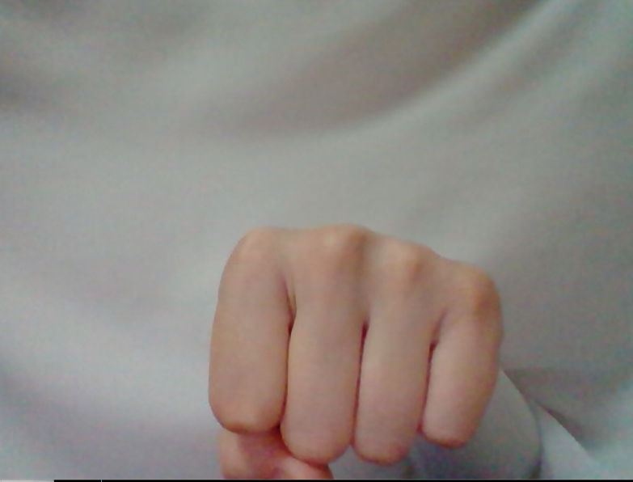

Yes

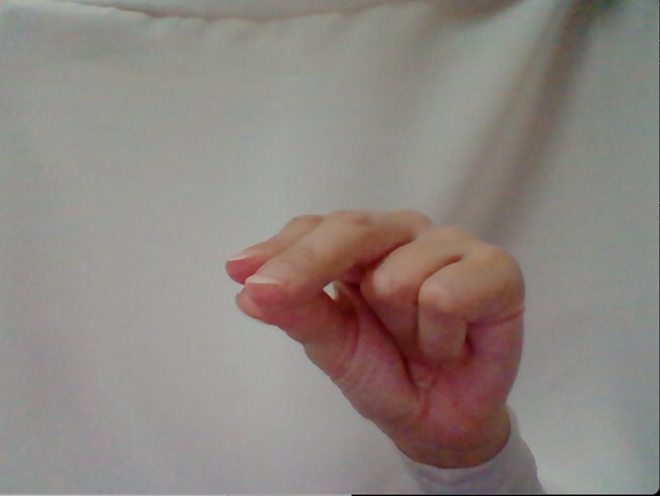

No

Bathroom

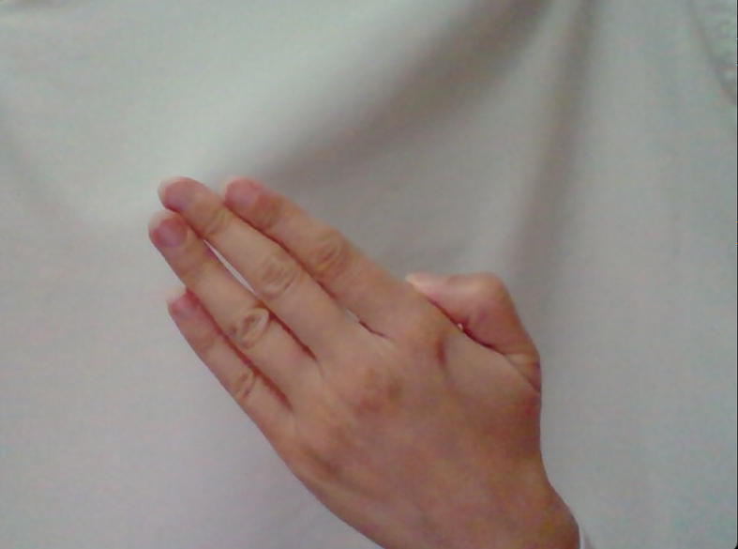

Thank you

Fine

Help

I, Me